# Inheritance in Java

**Inheritance in Java** is a mechanism in which one object acquires all the properties and behaviors of a parent object. It is an important part of OOPs (Object Oriented programming system).

### Why use inheritance in java

* For Method Overriding (so runtime polymorphism can be achieved).
* For Code Reusability.

## Types of inheritance in java

On the basis of class, there can be three types of inheritance in java: single, multilevel and hierarchical.

In java programming, multiple and hybrid inheritance is supported through interface only. We will learn about interfaces later.

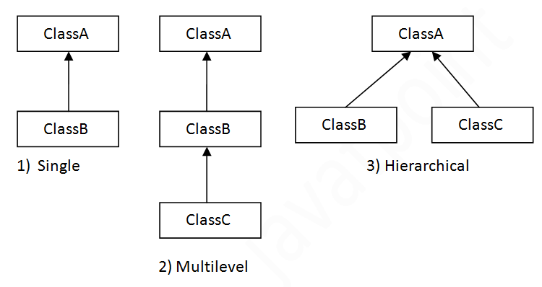

When one class inherits multiple classes, it is known as multiple inheritance. For Example:

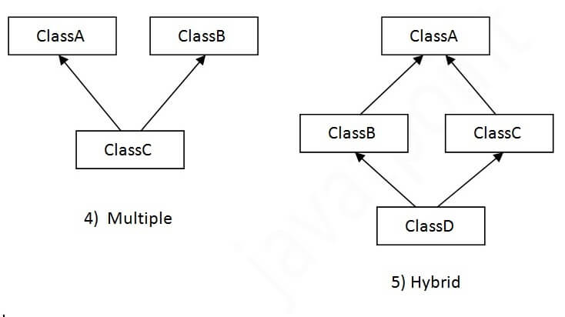

## Single Inheritance Example

package ex;

class sub1{

void m1(){

System.out.println("im base class");

}

}

public class Inheritance extends sub1 {

void m2(){

System.out.println("im derived class");

}

public static void main(String[] args) {

Inheritance i=new Inheritance();

i.m2();

i.m1();

sub1 s=new sub1();

s.m1();

}

}

## Multilevel Inheritance Example

package ex;

class sub1{

void m1(){

System.out.println("im base class");

}

}

class sub2 extends sub1{

void m2(){

System.out.println("im base class");

}

}

public class MultilevelInheritance extends sub2{

void m3(){

System.out.println("im derived class");

}

public static void main(String[] args) {

MultilevelInheritance m=new MultilevelInheritance();

m.m3();

m.m2();

m.m1();

sub2 s2=new sub2();

s2.m1();

s2.m2();

sub1 s1=new sub1();

s1.m1();

}

}

## Hierarchical Inheritance Example

package ex;

class sub1{

void m1(){

System.out.println("im base class");

}

}

class sub2 extends sub1{

void m2(){

System.out.println("im derived class");

}

}

public class HierarchicalInheritance extends sub1{

void m3(){

System.out.println("im derived class");

}

public static void main(String[] args) {

HierarchicalInheritance h=new HierarchicalInheritance();

h.m1();

h.m3();

sub2 s2=new sub2();

s2.m1();

s2.m2();

sub1 s1=new sub1();

s1.m1();

}

}